COTP Automation Properties File

Please read and follow the directions below to get started

Directions to get started on windows

1. Download folder COTP 0.1 folder. Unzip it and place the COTP 0.1 folder on your desktop
   1. It will contain the following files:
      1. Chromedriver - leave alone
      2. Properties.py - open with notepad (or text editor) to edit
      3. Python-3…..exe - Python installer(version may update) double click to run
      4. installSelenium.bat - double click to run
      5. cotp.py - double click to run when ready
2. Edit properties.py - this can be done in notepad or any simple text editor
   1. Enter your phone number, country code, password
      1. If you know IFTTT you can play with your own Webhook Triggers Optional..
   2. Save
3. Run the python installer.
   1. Be sure to check off installing PIP and adding python to environmental variables while installing.

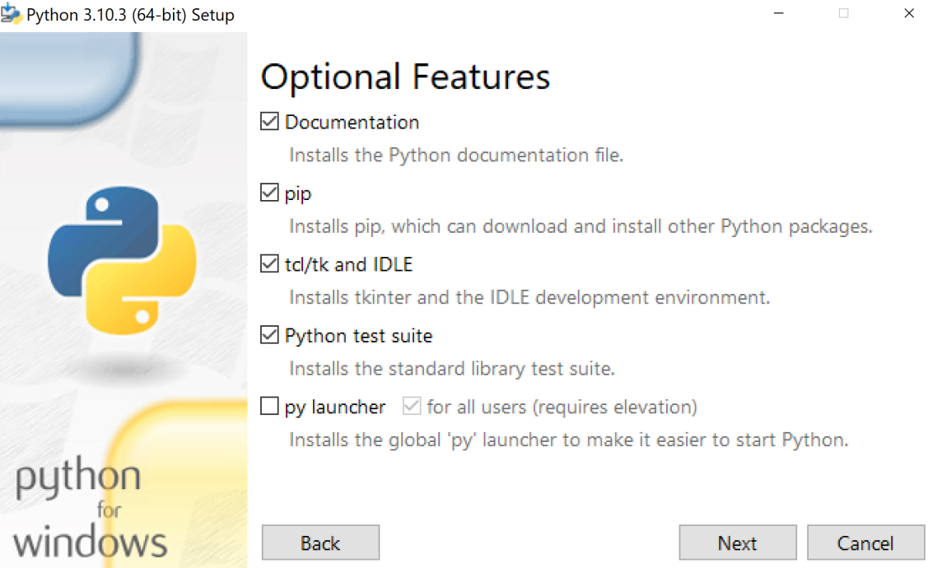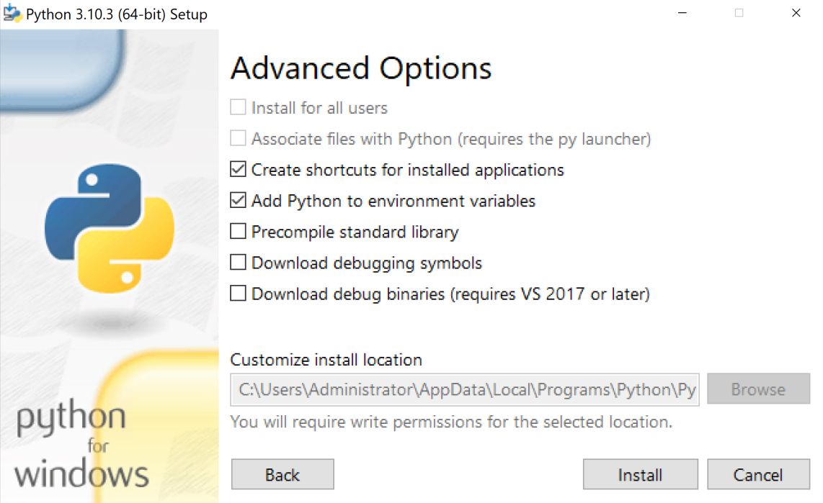

1. Run the installSelenium file by double-clicking it
   1. This will install the selenium library for python’s use. You can alternatively look up how to install selenium for python and install via command prompt.
2. Find your Machine's Name
   1. Run the file called "Run for Machine Name"
   2. this will give you a read-out of your machine's name. You will need to send this in for your script to work.
3. Run the run file by double-clicking it
   1. Everything should be set up for you to run COTP automatically. Watch it complete its first cycle. It should give a message in the terminal that it is waiting 2 hours before checking again.
   2. Leave the terminal window open and running. You can close down your connection to the VPS/VM and it will continue to do its thing.